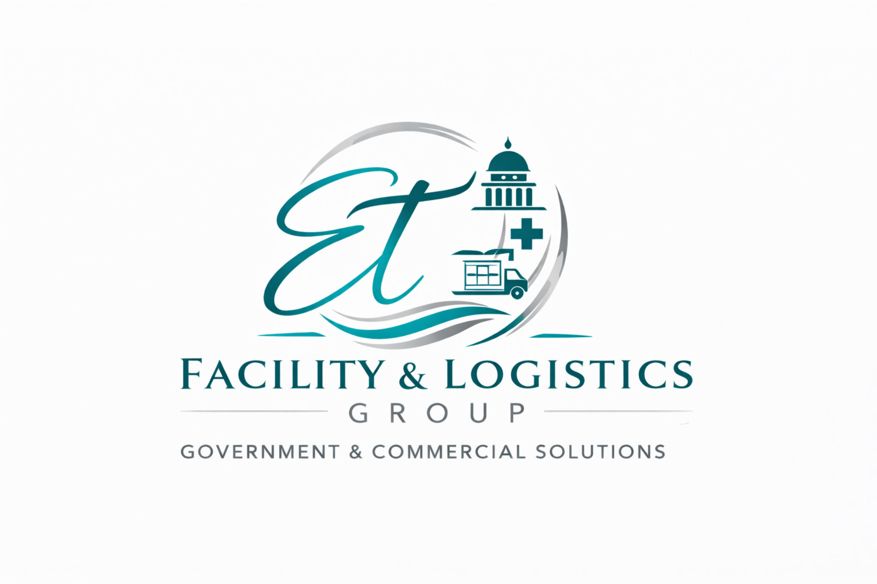 | ET Facility & Logistics Group  Government & Commercial Solutions

■ Procurement Support ■ Supply Distribution ■ Contract Fulfillment
Company Overview  ET Facility & Logistics Group provides procurement support and supply distribution services for government agencies, commercial organizations, and healthcare environments. The company assists organizations with sourcing, purchasing coordination, and distribution of operational supplies and equipment.  Our procurement services support organizations that require dependable supply sourcing, vendor coordination, and efficient distribution of essential operational materials.  Core Services  • Office Supplies Distribution  • Janitorial Supplies Distribution  • Medical Supply Procurement  • Contract Purchasing Support  • Supply Coordination & Distribution  Past Performance  Operational support experience within healthcare environments  • Logistics coordination and supply distribution support  • Facility sanitation and janitorial services support  • Administrative and operational workflow coordination  Contact  Nikita Lawson  contracts@ellagantelitecare.com  Atlanta, Georgia  ellagantelitecare.com   | Company Data  UEI: LTF7FVMANWL7  CAGE Code: 190R5  SAM.gov Registered Vendor  Small Business  Georgia-Based Contractor  Core NAICS  423850 – Janitorial Equipment & Supplies  423450 – Medical Equipment & Supplies  424130 – Industrial & Janitorial Chemicals  Certifications & Training  • OSHA Hazard Communication Training  • Bloodborne Pathogens Awareness  • PPE Safety Training  • HIPAA-Aware Service Practices  • Lean Six Sigma Yellow Belt (AIGPE™)  Differentiators  • Small business responsiveness and flexible service delivery  • Multi-service operational support (facility, logistics, procurement)  • Compliance-aware service practices  • Scalable support for commercial and government environments

