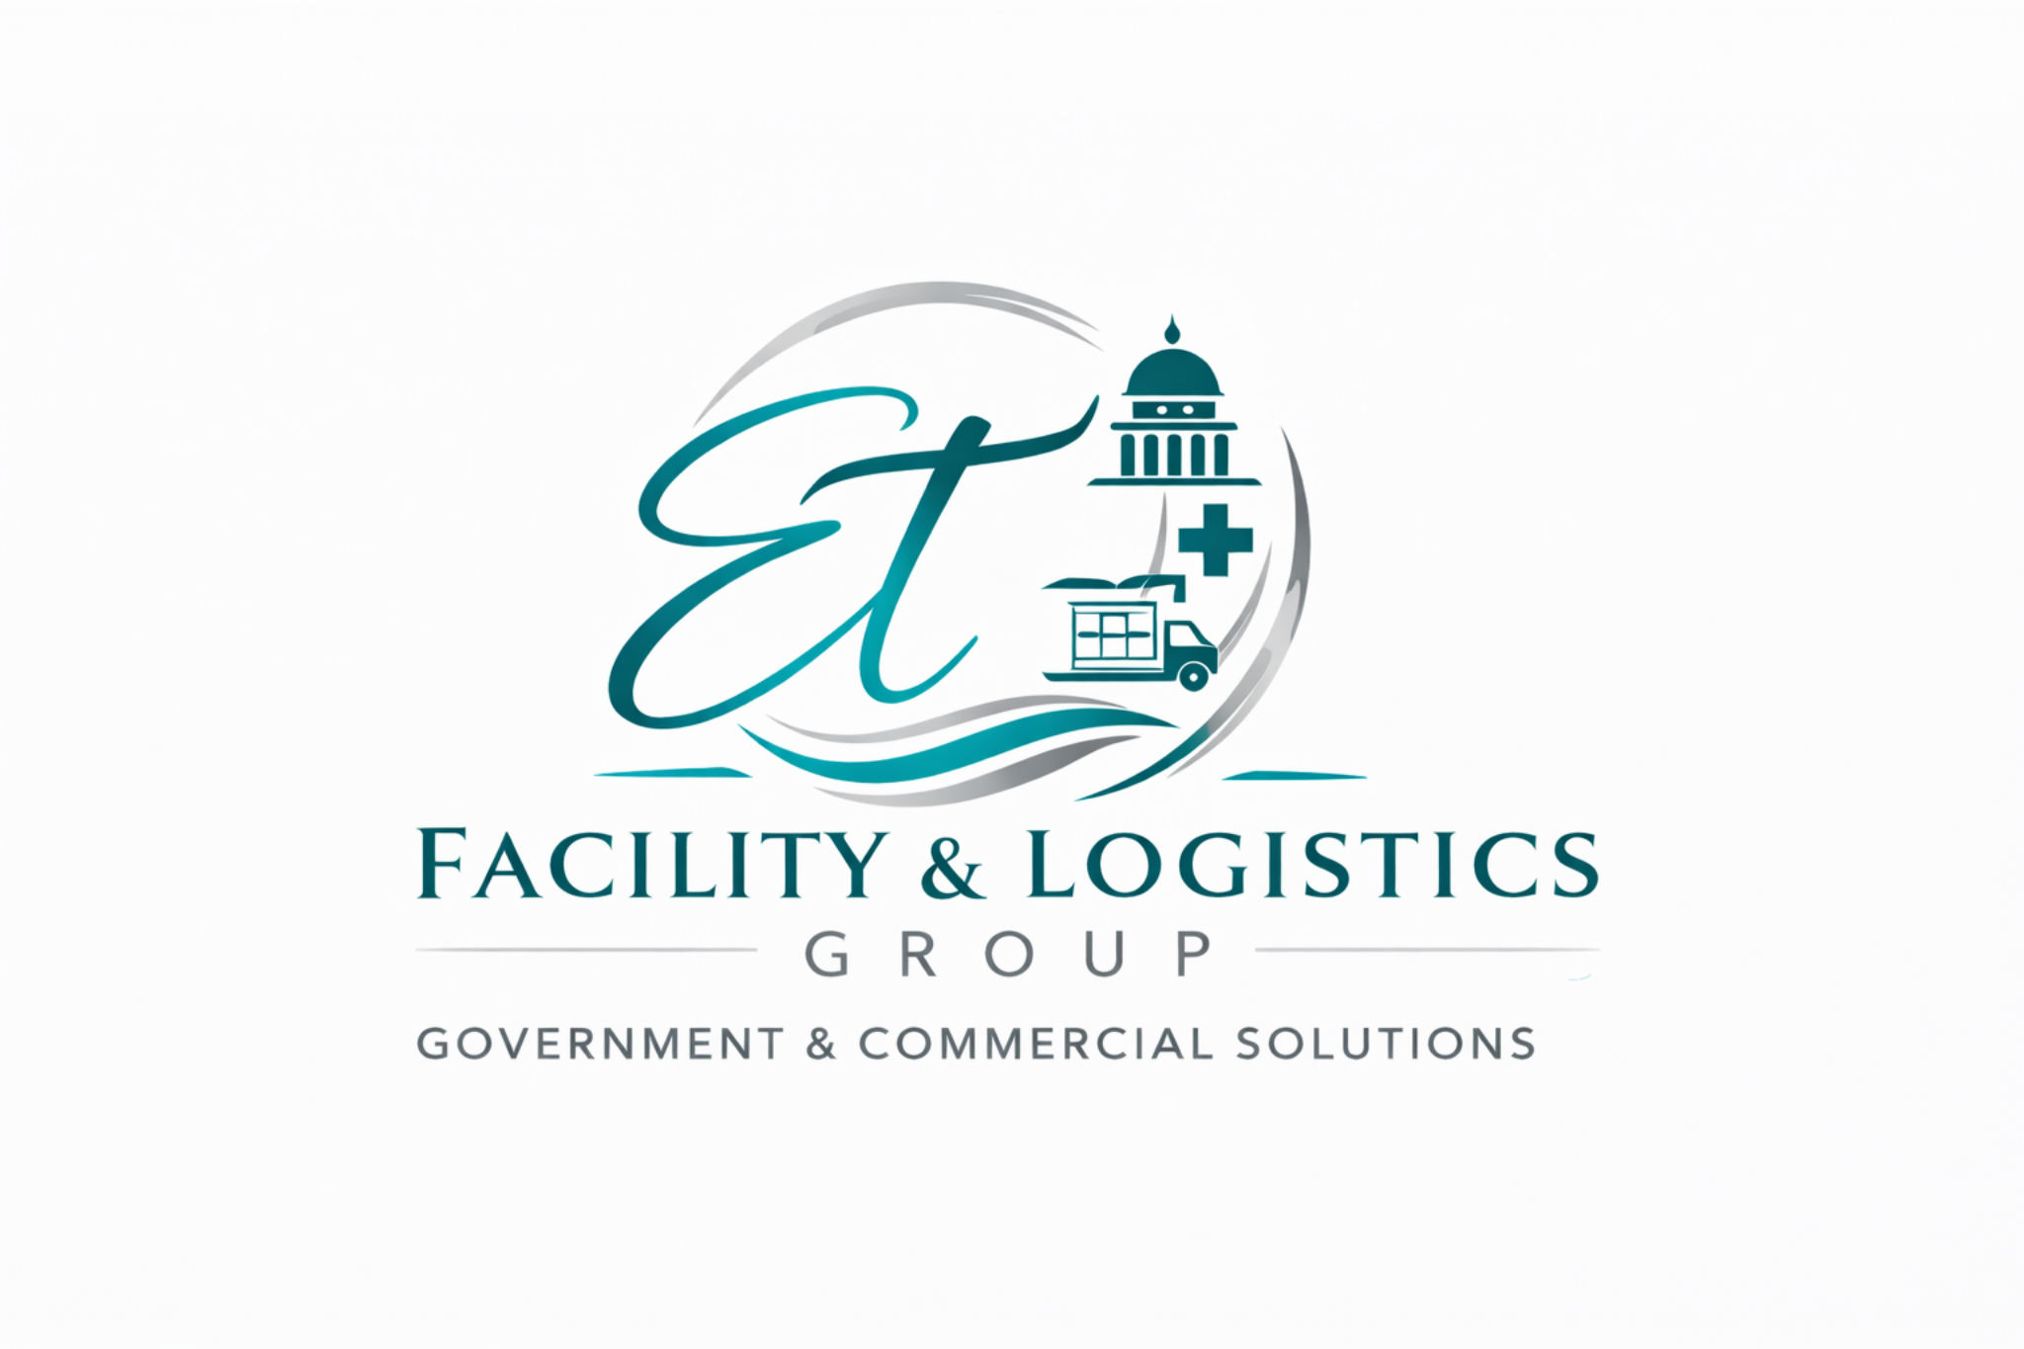 | ET Facility & Logistics Group  Government & Commercial Solutions

■ Facility Services ■ Night Cleaning ■ Facility Support
Company Overview  ET Facility & Logistics Group provides professional facility services and janitorial support for corporate offices, government facilities, and commercial environments. The company focuses on maintaining clean, safe, and well-maintained operational environments through structured sanitation processes and reliable service delivery.  Services are typically performed during scheduled or after-hours service windows to minimize disruption to daily operations.  Core Services  • Commercial Office Cleaning  • Night Cleaning & After-Hours Janitorial Services  • Restroom Sanitation & Maintenance  • Trash Removal & Facility Sanitation  • Floor Care & Surface Cleaning  • Facility Support for Administrative Environments  Past Performance  Operational support experience within healthcare environments  • Logistics coordination and supply distribution support  • Facility sanitation and janitorial services support  • Administrative and operational workflow coordination  Contact  Nikita Lawson  contracts@ellagantelitecare.com  Atlanta, Georgia  ellagantelitecare.com   | Company Data  UEI: LTF7FVMANWL7  CAGE Code: 190R5  SAM.gov Registered Vendor  Small Business  Georgia-Based Contractor  Core NAICS  561720 – Janitorial Services  561210 – Facilities Support Services  Certifications & Training  • OSHA Hazard Communication Training  • Bloodborne Pathogens Awareness  • PPE Safety Training  • HIPAA-Aware Service Practices  • Lean Six Sigma Yellow Belt (AIGPE™)  Differentiators  • Small business responsiveness and flexible service delivery  • Multi-service operational support (facility, logistics, procurement)  • Compliance-aware service practices  • Scalable support for commercial and government environments

